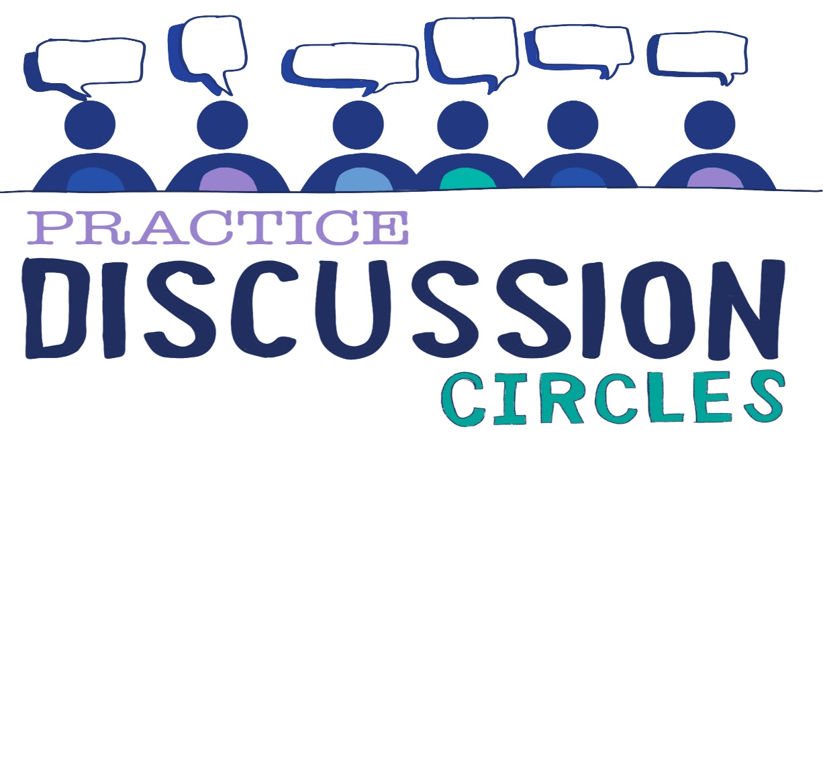



**Check In:** If you could be any Disney Villain, who would you be?

**Game:** Pulse Train

*You will need a Tea Towel and a Coin*

*Instructions for play: Group split into two equal teams, seated in two lines, facing each other one metre apart. On an extra chair at one end is a tea towel or easy to grab object. It should be within easy reach of both players who are in the last chairs of their respect teams. The Circle Keeper is at the other end of the line with a coin. Each chair needs to be touching the next. Teams are told that the Circle Keeper will thrown the coin in the air and if it lands on ‘heads’ each team must send a ‘pulse’ down their line. When it reaches the person at the end they must try to grab the towel first. The team that gets the towel wins.*

*Everyone, except the first person in each team nearest the Circle Keeper, must have their eyes closed. If the coin lands on tails you must not send the pulse. If you do and your team grabs the tea towel the other team wins a point. If the teams grab the towel at the same time no points are awarded.*

*When a point is one, the people who trying to grab the towel walks to the other end of the line and takes up the position next to the Circle Keeper and everyone moves down one.*

*Purpose: Concentration, cooperation, team building,*

**Question for discussion:** How does shame show up in behaviours in the classroom and/or your organisation?

**Reflective Question:** What do you need to feel safe and reintegrate those feelings of shame to be able to move on from it?

**Check Out:** Something you are taking away from today and something you’d like to explore further

“Nobody can actually feel another’s pain or grief, another’s love or joy or hunger. And similarly, nobody can experience another’s understanding of a given event or situation” ***Aldous Huxley***

Check in