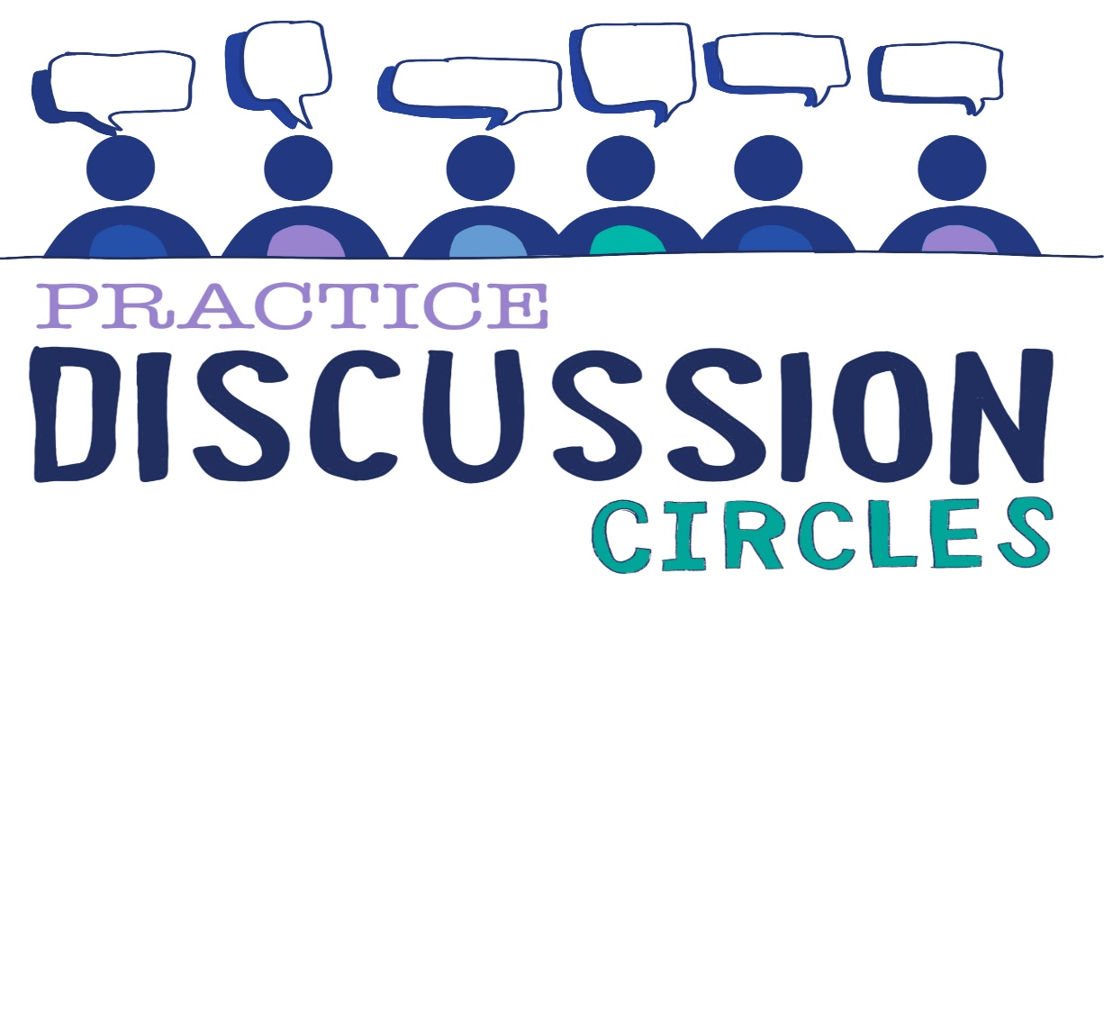

Check in



**Check In:** Who is your favourite partnership and what is it about them that speaks to you?

**Game:** Make Together

*Sheets of paper needed for this activity*

*Instructions for play: Participants get into pairs. Circle Keeper asks them to put one arm behind their back.*

*Give each pair a sheet of paper and ask each pair to make a paper airplane. Each person can only use one hand (and not the one they nominated behind their back). Encourage them to work together and make it a shared project. They have 3 minutes to complete the task*

*The planes can then be flown as a competition to see which one goes furthest, does most loop the loops, takes the shortest time to reach the floor etc*

*Purpose: Group building, collaboration, problem solving,*

**Question for discussion:** What are the different behaviours have you seen in your classroom/organisation and which attachment style do you feel they would fit.

**Reflective Question:** What would constitute an attachment-aware response when a child or young person is demonstrate attachment needing distress behaviours

**Check Out:** Something you are taking away from today and something you’d like to explore further

“Nobody can actually feel another’s pain or grief, another’s love or joy or hunger. And similarly, nobody can experience another’s understanding of a given event or situation” ***Aldous Huxley***