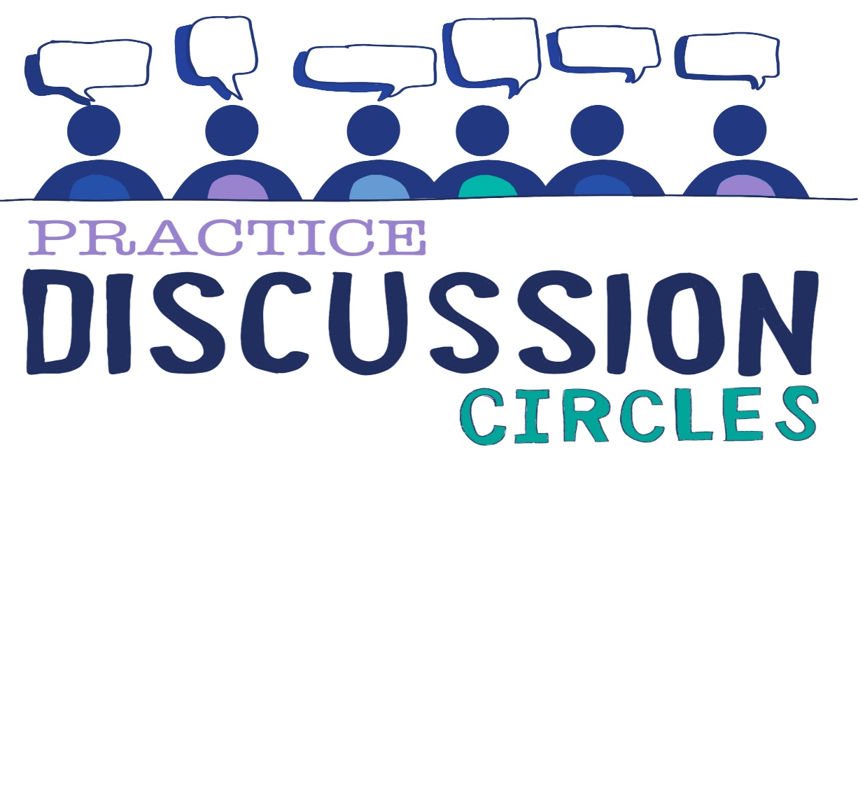



**Check In:** Share 3 words that describe your day

**Game:** Sock Game

*Instructions for play: You will need a number of pairs of socks (approx. 8 pairs for a circle of 20).*

*Begin with participants standing in a circle and throwing a pair of socks to someone roughly across the circle in an easy to catch arc. The person who has just received the socks does the same, throwing it to someone roughly across the circle from them. They then fold their arms to let the other people not to throw the socks to them again. In this way the socks will be thrown to each person only once, then back to you. You should be the last person to receive the socks. Advise participants to remember who threw to them, and who they threw to.*

*Participants then throw in the same pattern again. When they are confident reverse the pattern so that they then receive the socks from the person they threw to. When they confident about the pattern send the socks around the circle adding in more pairs of socks to the sequence and see how many pairs the group can tolerate without dropping them.*

*Purpose: Group building, cooperation, problem solving. Managing multiple things happen at once.*

**Question for discussion:** What sits with you about the impact of Trauma?

**Reflective Question:** How can you support a young person to be more compassionate towards themselves?

**Check Out:** Something you are taking away from today and something you’d like to explore further

“Nobody can actually feel another’s pain or grief, another’s love or joy or hunger. And similarly, nobody can experience another’s understanding of a given event or situation” ***Aldous Huxley***

Check in