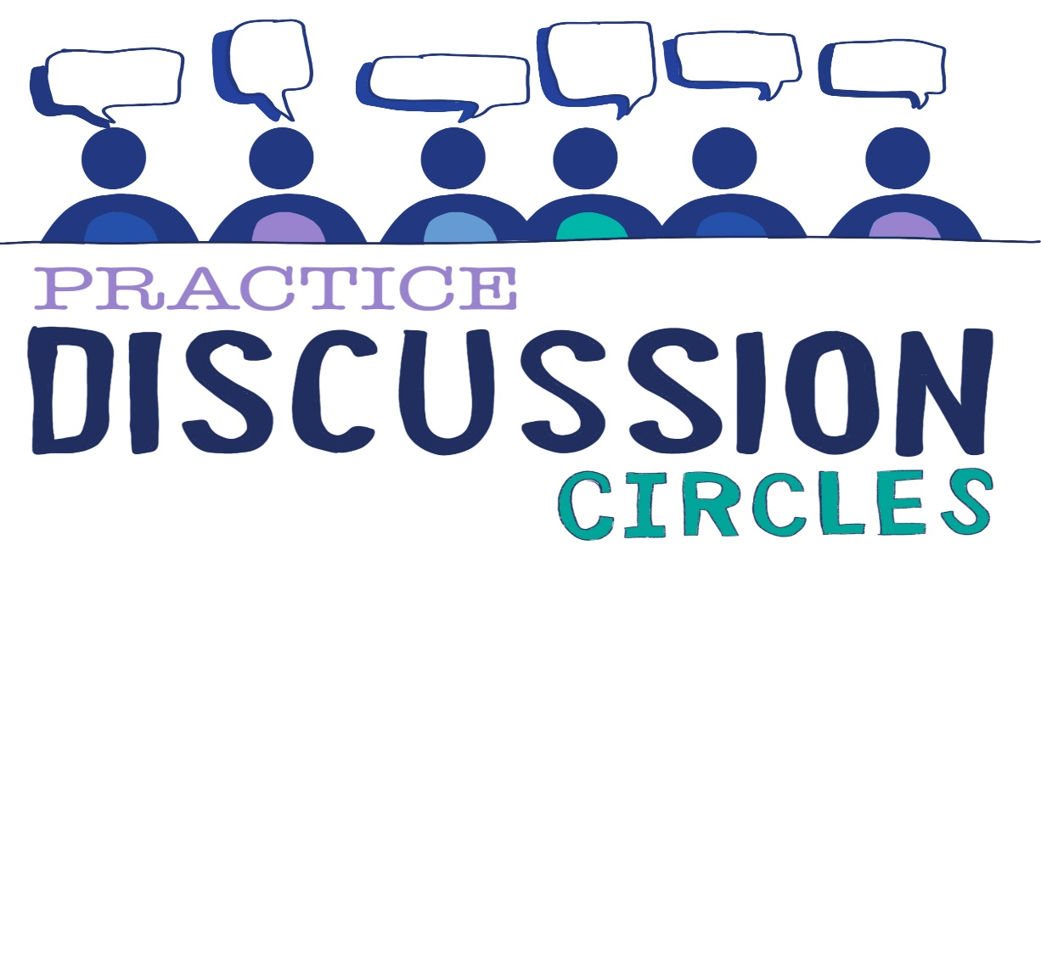



**Check In:** Do you squeeze your toothpaste or roll it?

**Game:** Empty Chair

*Instructions for play: Participants are asked to move their chair anywhere in the room, facing any direction. Once they are settled they cannot move their chairs. When they are settled, place an empty chair somewhere within the room, and then stand at the opposite end so that you are some distance away. Explain to the participants that are you are going to walk, at a steady pace, towards the empty chair. Their job is to try to prevent you from sitting in an empty chair. They cannot touch you, block you, trip you – they are just going to attempt to get to the empty chair before you. As they leave their chair, that becomes ‘the empty chair’ and you will change direction and head for that one, continuing at your steady pace. Once a participant begins to leave their chair, they must keep going, they cannot sit back down or return to the chair they left. They must try to keep you from sitting down for one minute. If you manage to sit down within that time they have lost. To develop the game you may give them time to form a strategy.*

*Purpose; Team building, communication, problem solving, cooperation,*

**Question for discussion:** Thinking about the Window of Tolerance and Bruce Perry’s video of our brains under stress, what responses have you noticed in others that indicates their window of tolerance has shrunk?

**Reflective Question:** What routines do you have to keep your stress levels predictable, moderate and controllable?

**Check Out:** Something you are taking away from today and something you’d like to explore further

“Nobody can actually feel another’s pain or grief, another’s love or joy or hunger. And similarly, nobody can experience another’s understanding of a given event or situation” ***Aldous Huxley***

Check in