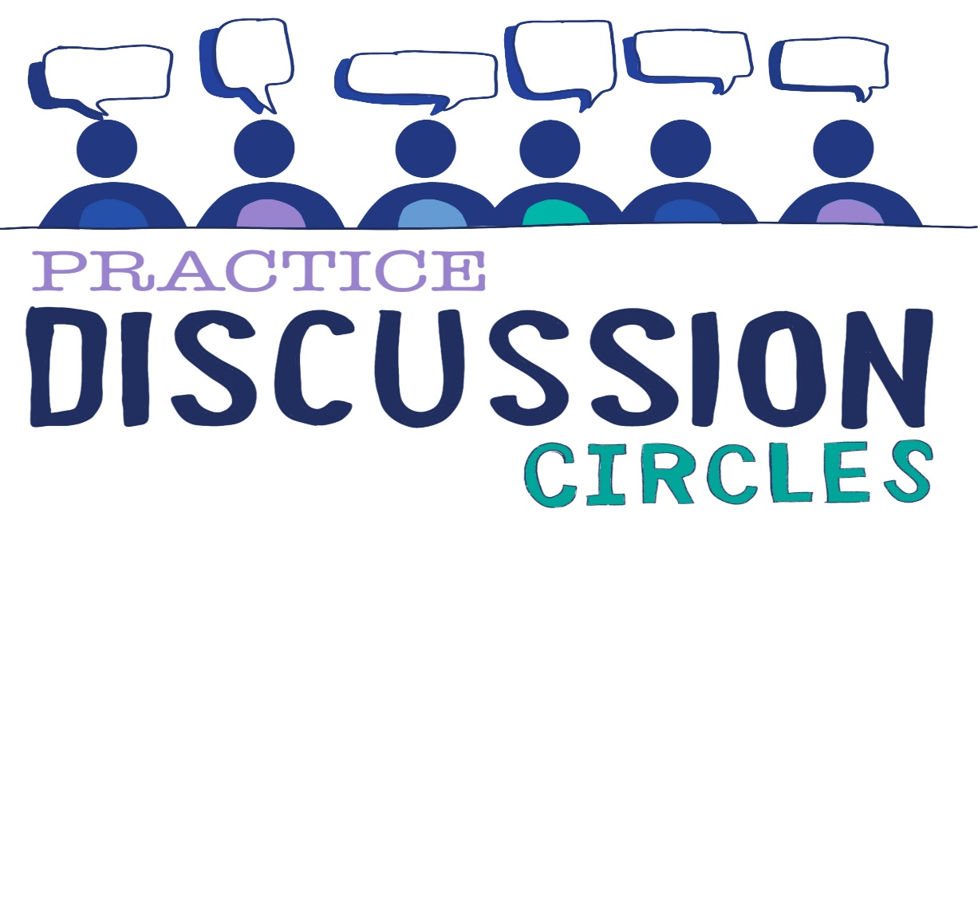

**Check In**: One skill or natural talent you wish you had

**Game:** 1,2,3

*Get into pairs and face your partner. Each pair are going to take it in turns to say one number at a time. So Person A and Person B are going to demonstrate. A will say 1, B will say 2, A will say 3, then B will go back to 1. (demonstrate with a participant). Off you all go.*

*This time we going to change it a bit. You are going to do this all again, except this time you are going to take away saying the number 2. Instead, for 2, you are going to click your fingers. So A will say 1, B will click their fingers but they won’t say 2, and A will say 3. Then B will say 1, A will click fingers and B will say 3 (again demonstrate and then send off to try)*

*Now you’ve mastered that you are going to not only remove number 2, but also number 1. So now for number 1, there will be a clap. So A won’t say 1 they’ll clap, B will click fingers for 2 and then A will say 3. B then claps, A clicks their fingers and B says 3. (again demonstrate and then send off to try)*

*Now you are going to get rid of all the numbers but you are going to make up your own number 3 in your pairs. It must have a movement and sound but can be anything. So my partner and I are going to punch the air and say ‘Yehaw!’ instead of three. It looks like this: A claps, B click, A yehaw’s and punches air), Remember each pair can pick their own action and sound for number 3 (again demonstrate and then send off to try)*

**Question for discussion:** What sits with you around SEND and how this tessellates with ACEs, Trauma and Relationships?

**Reflection:** How are you going to create options to be curious withing your setting?

**Check Out:** Something you are taking away from today

Something you would like to explore further

Check in