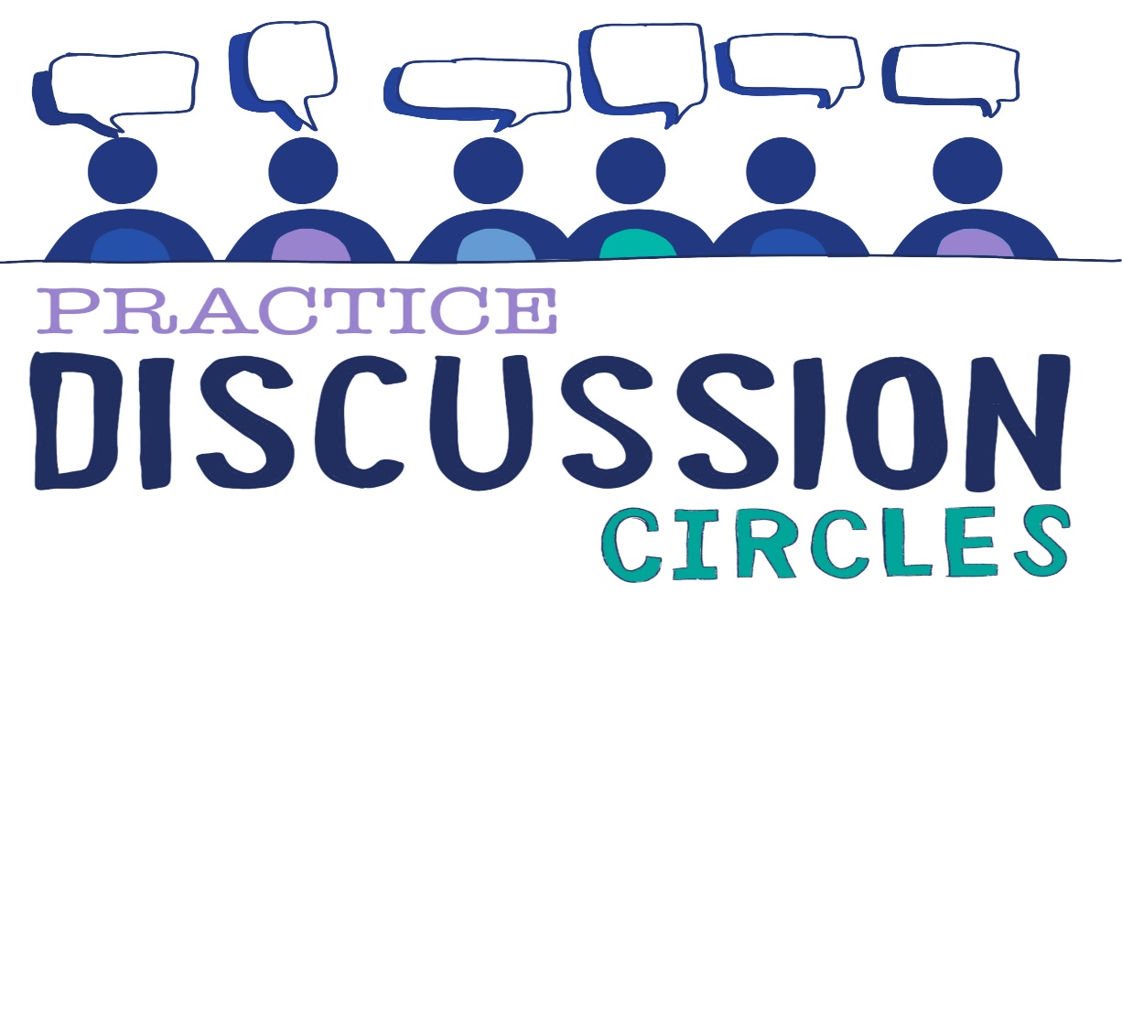

Co-regulation

Check In: One thing that brings you energy and joy

Game: 3 minute meditation (Sam can we link voice note Simon shared here?)

Question for discussion: What do adults sometimes do that might cause a child to feel dysregulated?

Reflection: In groups design what you might see, hear, or feel for each of the four S’ (Safe, Seen, Soothed, Secure) in your setting.

*You will need large paper and felt pens. In groups of approx. 6 spend 10 minutes on the design. Then put all the group designs together and share what you notice as a whole team*

Check Out: Something you are taking away from today

Something you would like to explore further

Check in