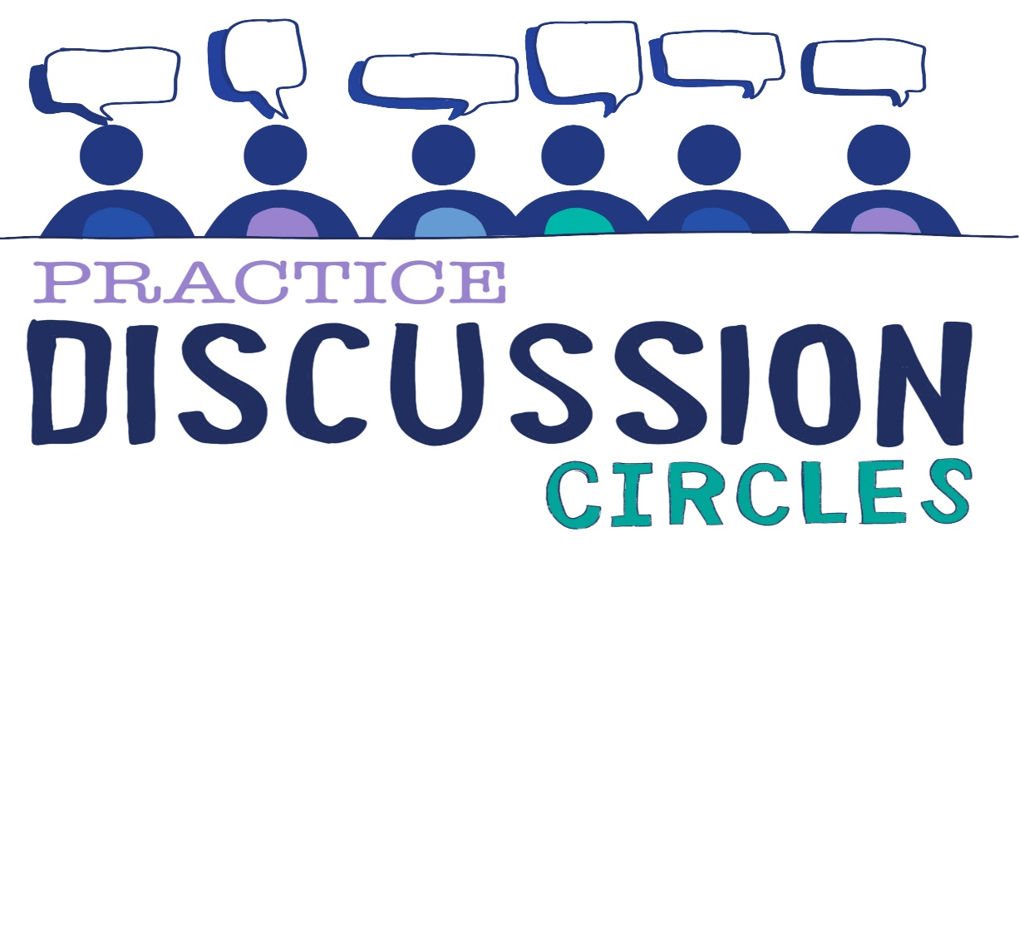



**Check In:** If you could advise your 15 year old self what would you say?

**Game:** Blind drawing –

*Need paper, pens and Blind Drawing Materials*

* *Group in pairs and sit back to back. Get participants to choose who is A and who is B*
* *Person a is the drawer and person b describes the picture/shapes in front of them. Person B is the only person to speak. Person A cannot ask questions but must just draw what is described. They have 5 minutes.*
* *Then swap roles Person B becomes drawer and Person A the describer. This time the drawer (Person B) can ask clarifying questions. They have 5 minutes.*

*Purpose: Connection, Communication, Listening. Experiencing being told and collaborating on a piece of work*

**Question for discussion:** We have looked at both a behaviourist approach and a humanist approach. What things influence the way we respond to behaviour.

**Reflective Question:** Think of a time when you have had to respond to a young person at work or at home in a humanist/restorative way. What happened, what did you think/feel?

**Check Out:** Something you are taking away from today and something you’d like to explore further

“Nobody can actually feel another’s pain or grief, another’s love or joy or hunger. And similarly, nobody can experience another’s understanding of a given event or situation” ***Aldous Huxley***

Check in