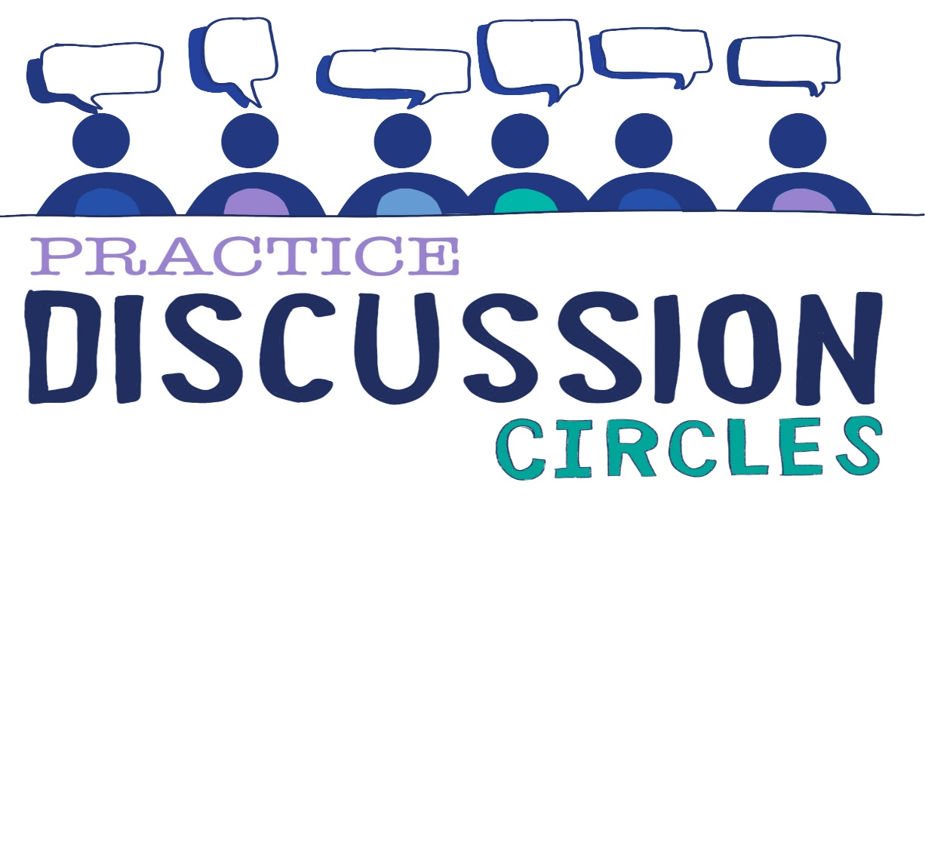



**Check In:** If you had £200 you could spend on anything, what would you spend it on?

**Game:** One word Story

*Instructions for play: Participants will tell a story each saying only one word as they go around the circle in turn. The story starts ‘Once upon a time’ so the first four participants will start this off saying this one word each. The story continues around the circle with each participant putting forward a word. Participants do not use any punctuation words such as ‘full stop’ as the story is allowed to shift as it needs to. Allow the story to go around the circle for several rounds.*

*Purpose: Listening, communication, concentration, letting go of control*

**Question for discussion:** What are skills and attitudes needed to support relational and restorative communication?

**Reflective Question:** List the attitude or qualities someone might have to support effective restorative dialogue and communication?

**Check Out:** Something you are taking away from today and something you’d like to explore further

“Nobody can actually feel another’s pain or grief, another’s love or joy or hunger. And similarly, nobody can experience another’s understanding of a given event or situation” ***Aldous Huxley***

Check in