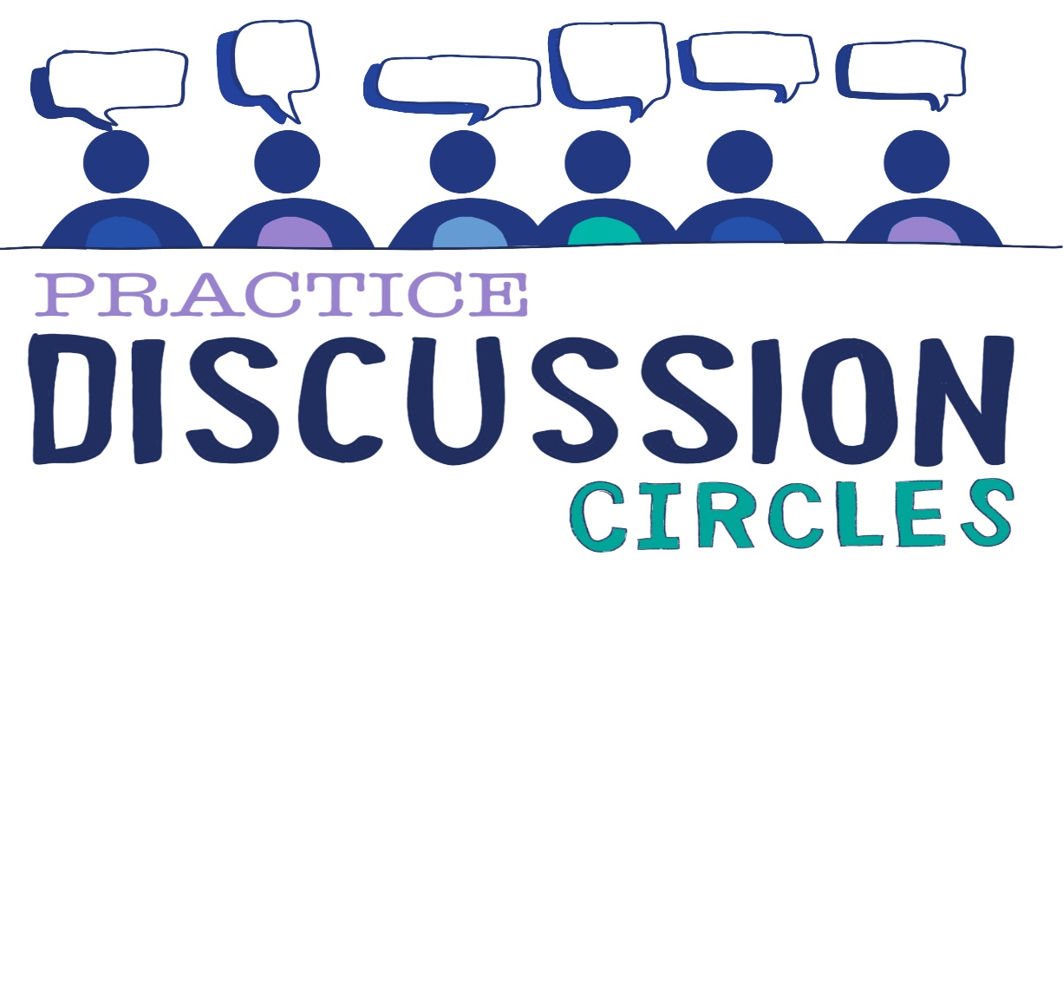



**Check In:** Where is your path leading you to today?

**Game:** Zip, Zap Boing

*Instructions for play: Explain that each of these words has an action to go along with them. Starting with a Zip, we are going to put our hands flat together and passing the Zip to the person next to you. Imagine that this is a bolt of electricity so pass it quickly. Practice sending the Zip clockwise, then anti clockwise. After some practice stop and introduce Boing. Explain that at the moment the Zip can only go one way once it has started, so the Boing will allow us to change direction. When a Zip comes to you now, you can now put out both hands facing flat out in front of you to ‘refuse it’ and pass it back as you say Boing. The person passing the Zip to you must now turn and pass it back the other way. After a practice with these two moves, introduce Zap. So we have seen Boing can get things stuck so we are going to add Zap. You can Zap at anytime. To Zap, put your hands flat together just like a Zip, but this time make eye contact with someone across the circle and Zap the electric bolt across, pointing at them and saying Zap. The receiver now can choose whether to Zip either side or Zap someone else across the circle. However you cannot Boing a Zap, nor can you Zap the person who Zapped it to you.*

*Purpose; Energiser, communication, focus*

**Question for discussion:** Considering the change models, which one resonates with you? Have you experienced change using this model?

**Reflective Question:** Having drawn on your experience of change, which elements made it successful?

**Check Out:** Something you are taking away from today and something you’d like to explore further

“Nobody can actually feel another’s pain or grief, another’s love or joy or hunger. And similarly, nobody can experience another’s understanding of a given event or situation” ***Aldous Huxley***

Check in