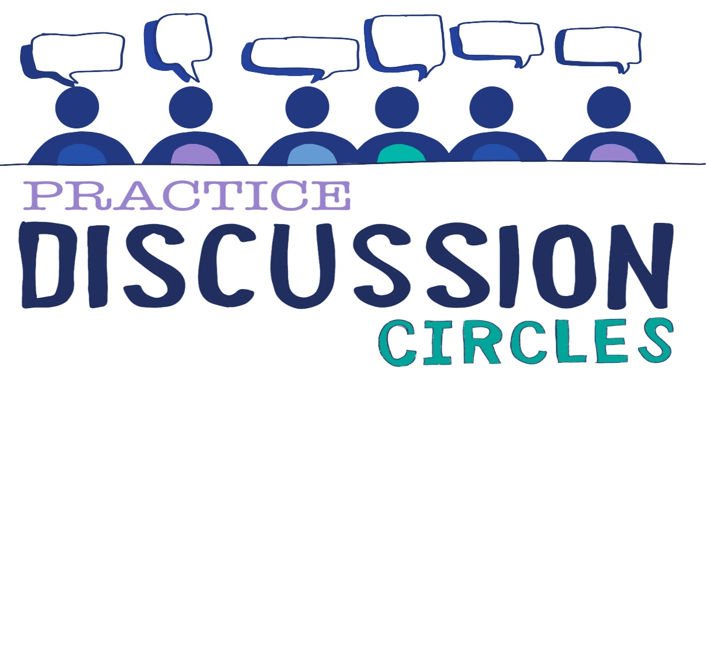



**Check In:** One person in your life you especially respect. What is it about them that makes you feel that?

**Game:** Bomb/Shield

*Instructions for play: Everyone needs to be spread around the room randomly so participants are encouraged to walk around in any direction. When you call STOP, participants stand still. Participants are then asked to look around the room silently and identify two people in their minds eye and keep this to themselves. Keeping these people in your minds eye and not sharing with anyone, label one person as a ‘Shield’ and the other person as a ‘Bomb’. You need to keep your shield between you and your bomb at all times. Distance is not a factor but be careful to not bump into people. Be aware that other participants will be trying to do the same for their two people and no one knows who their people are. Run a practice session for 30 seconds. Then get participants to pick two new people and run for around 1 minute.*

*Purpose: Energiser, concentration, bomb identifies as impact from adverse experience and shield as positive experience/protector*

**Question for discussion:** What might we see, hear and feel in someone who has experienced ACES?

**Reflective Question:** What positive Childhood experience speaks to you?

What other positive experiences can you think of?

**Check Out:** Something you are taking away from today and something you’d like to explore further

“Nobody can actually feel another’s pain or grief, another’s love or joy or hunger. And similarly, nobody can experience another’s understanding of a given event or situation” ***Aldous Huxley***

Check in