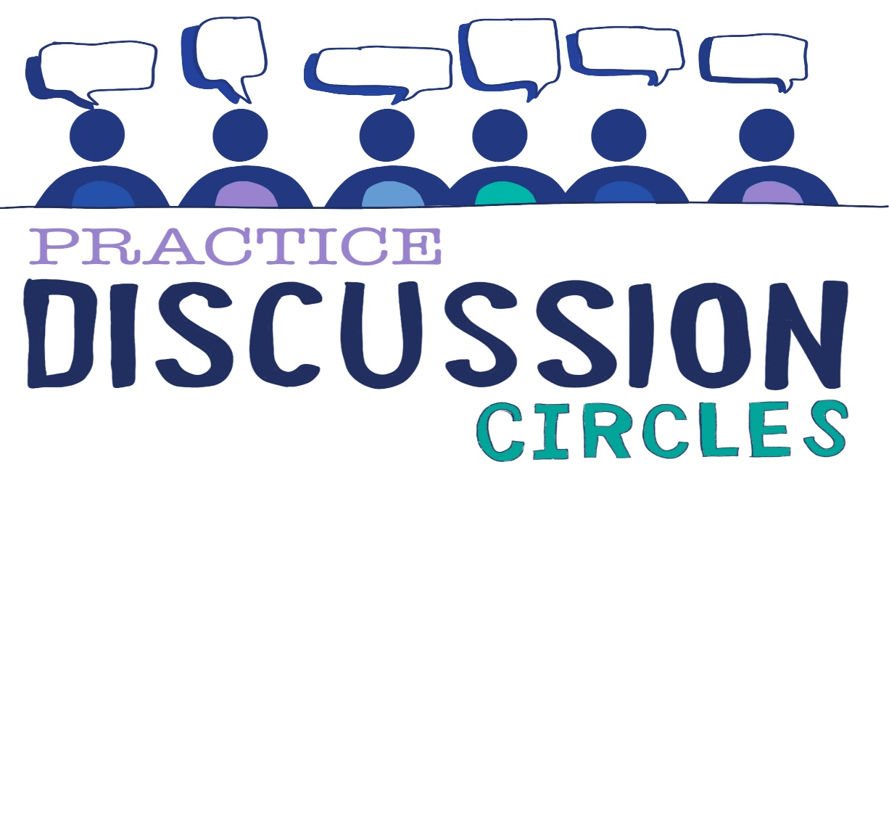



**Check In:** If you took the stripes off a Zebra what colour would it be?

**Game:** Movement Line

*Instructions for play: Participants will stand in lines of 10 in front of the Circle Keeper. Except for the participant next to the Circle Keeper everyone else faces the opposite direction so that their backs are facing the Circle Keeper. The line stands in silence with their hands by their sides. The Circle Keeper will show the participant facing them a series of physical moves (5 moves which the Circle Keeper will need to remember). The moves are only shown once. The participant then turns around, taps the person next to them on the shoulder and repeats the moves they have been shown. They must do this in silence and only once. The movement goes on down the line to the last participant. Once it has reached the end the last participant will stand out and show the Circle Keeper the moves that have been sent down the line.*

*Purpose; Movement, concentration, memory,*

**Question for discussion:** The area of restorative practices uses some language we might not be used to such as Harm and Harmer. What comes up for you when you hear these words?

**Reflective Question:** How does the concept of harm fit with a Trauma informed way of thinking?

**Check Out:** Something you are taking away from today and something you’d like to explore further

“Nobody can actually feel another’s pain or grief, another’s love or joy or hunger. And similarly, nobody can experience another’s understanding of a given event or situation” ***Aldous Huxley***

Check in